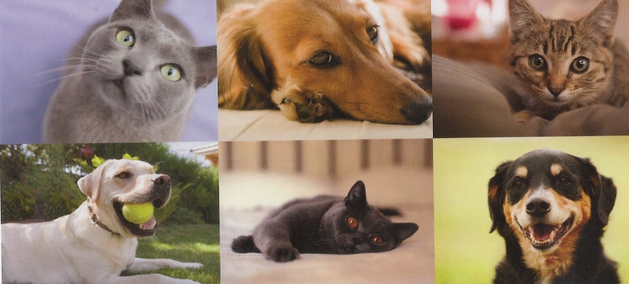

Aftercare For Your Recently Vaccinated Pet

Animal Protection & Education

515-500-3075 [www.GoAPE.info](http://www.GoAPE.info)

Many pets feel tired for a day or so after receiving a vaccination. This is because the immune system is working hard to make those antibodies and memory cells for the future,

Some pets will have mild soreness at the injection site. Local pain or soreness and lethargy for approximately 24 hours are very normal responses to vaccination.

it's important for you, the pet's owner, to be aware that if an allergic reaction takes place, it can happen immediately or up to 48 hours after vaccines have been administered. An allergic reaction is an aberrant response to the vaccination or, rather, an overreaction to the vaccine. Signs can be vomiting and/or diarrhea within the first few hours after administration of the vaccine. Puffiness may be noted, especially around the eyes, muzzle, and ears.

Another potential symptom is hives, or bumps, all over the body. If you notice any of these signs or if at any time you are concerned with how your pet is acting after vaccination, you should reach out immediately. Very rarely, anaphylactic reactions can occur in which a pet may collapse or even die moments after vaccination. Again, this is extremely rare.