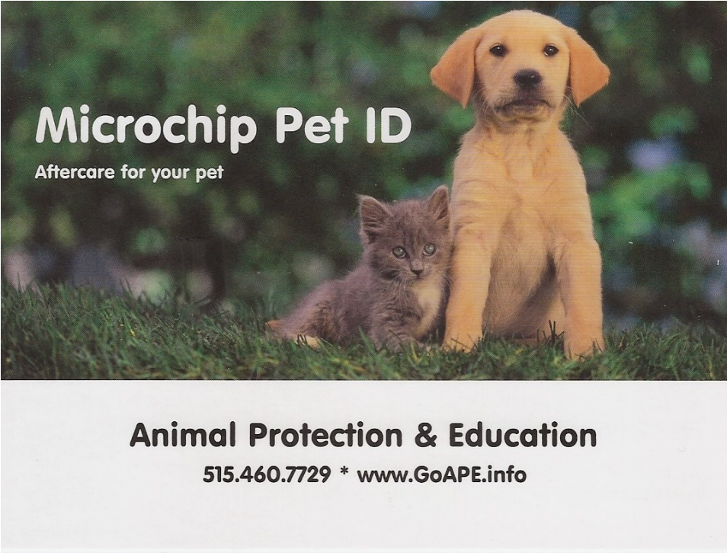

Animal Protection & Education

515-500-3075 * [www.GoAPE.info](http://www.GoAPE.info)

•The microchip is a permanent ID with a one-of-a-kind number. The ID cannot be lost, altered, or unintentionally removed.

•The microchip will last the animal's lifetime and will be registered online in the national database.

•If the animal finds a new family or the phone number or address changes, inform A.P.E. and the national database. This is important to ensure that if the animal gets lost, they will know how to get ahold of you!

